Data Types
Default values are applicable only to the data members (declared within a class) of the class not for local variables (declared within a method)
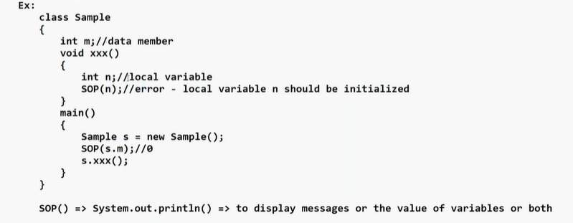

Local variables need to be initialized
Memory allocation for reference data type is done during runtime using new operator
Default value for reference data type is null
Ex.
String s; // data member
SOP(s); // null

Type Casting
Converting from one primitive data type into another primitive data type or converting from one reference data type into another reference data type is called as type casting

- Implicit Casting
converting lower data into higher data
automatically by JVM
No data loss
byte → short → int → long → float → double
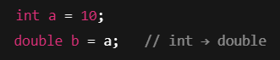

- Explicit Casting
Larger Smaller data type
Done manually
may cause data loss

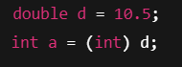
Type casting in Java is the process of converting one data type to another. It is of two types: widening (automatic conversion from smaller to larger type) and narrowing (manual conversion from larger to smaller type). In objects, it involves upcasting and down casting.
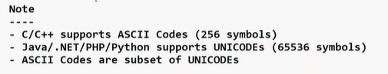

JShell tool
JShell tool is added in Java 9 version
JShell is an interactive tool to execute the Java statements

To Open JShell
Open command prompt /terminal
jdk > bin > JShell.exe


Operators
